A Taste of Your Own Medicine: Design and Architect Infrastructure for an Organization
Project Report: Designing AWS Architecture for Organizations

Your Information
Robert Saunders
October 18, 2026
Course Title: "Designing AWS Architecture for Organizations"
Executive Summary
Excipient Technologies, a leading pharmaceutical maker, is consolidating its AWS network architecture.
  - The company’s network includes:
    - An AWS Control Tower-based network.
    - A standalone AWS account created by a project manager.
    - An AWS Organizations-based network from an acquired business.
  - Your role as the senior cloud architect is to integrate these environments, establish network connectivity, enforce governance, and implement cost controls.
- Key Goals:
  - Integrate standalone and acquired accounts.
  - Enable secure and reliable interconnectivity.
  - Establish tagging strategies and governance.
  - Design cost management tools.

Multi-Account AWS Architecture Design (Step 1)
Objective: Design a multi-account architecture and integration strategy.

OU Hierarchy
- Scenario Details:
  - Design the organizational structure for Excipient Technologies. The company’s hierarchy must include:
    - Corporate OU: Centralized services (e.g., logging and auditing).
    - Workloads OU: Environments for applications like Development and Production.
    - Acquired Businesses OU: Temporary holding area for acquired accounts.
- Instructions:
  - Create a diagram representing the proposed OU hierarchy.
  - Include a brief explanation for each OU's role and purpose.
The following OU structure was designed to organize accounts for centralization and governance:
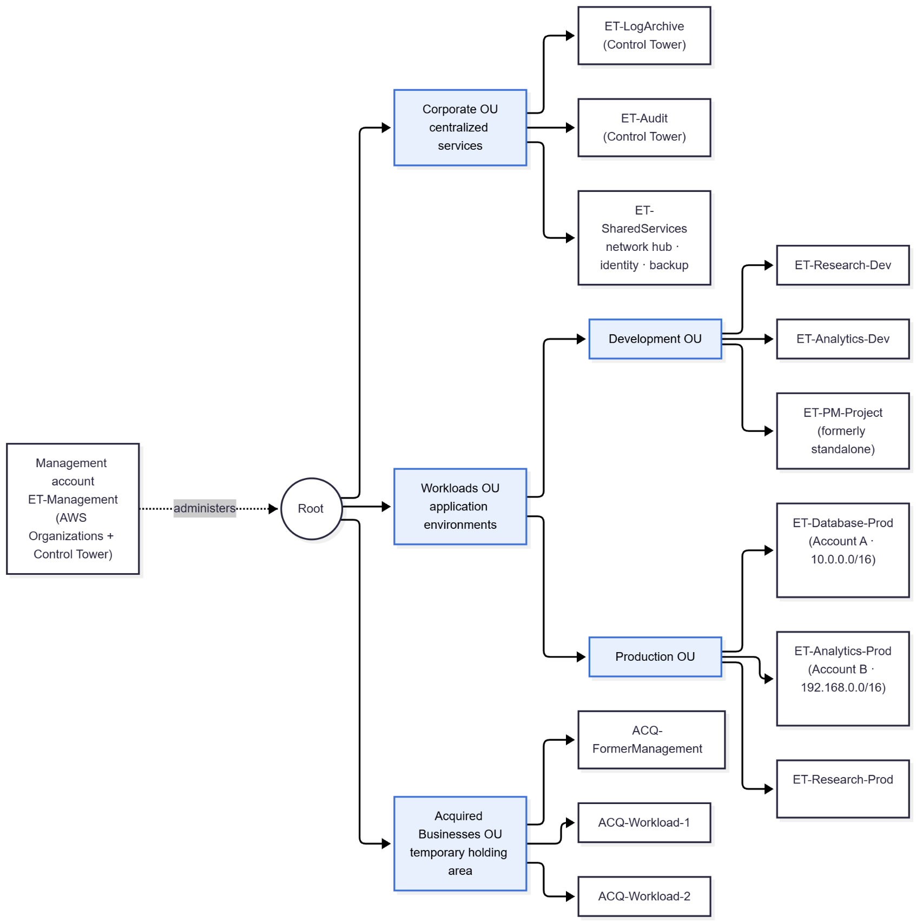
Provide your Explanation:
OU | Role and purpose | Accounts | Governance posture
Root | Top of the org, org-wide SCPs attach here | Management account (administers the organization; org SCPs don’t apply to it) | Baseline guard rails for everyone
Corporate | Centralized services: logging, auditing, and shared infra. This is the Control Tower foundational OU holding the Log Archive and Audit accounts (Control Tower lets you name it), plus a Shared Services account for the network hub, identity and backup | ET-LogArchive, ET-Audit, ET-SharedServices | Most restricted. Only security and platform teams have access. Mandatory controls protect the logs
Workloads | App environments: research, analytics, and product dev. Split by function (environment), not department, so one policy set covers every similar account | - Parent of the 2 below this | Encryption, tagging, and identity guardrails shared by Dev and Prod
Workloads/Development | Building and testing. Cost-limited. | ET-Research-Dev, ET-Analytics-Dev, ET-PM-Project | Instance-type limits and budget actions allowed
Workloads/Production | Live and validated workloads (including GxP-regulated systems) | ET-Database-Prod, ET-Analytics-Prod, ET-Research-Prod | Strictest change control. No automated stop actions.
Acquired Businesses | Temp holding area for acquired accounts while they’re assessed and remediated. Accounts graduate to Workloads once compliant. | ACQ-FormerManagement, ACQ-Workload-1, ACQ-Workload-2 | Quarantine-style SCPs: no new internet exposure, no new IAM users

Integration Strategy
Standalone and Acquired Account Integration visual flow:
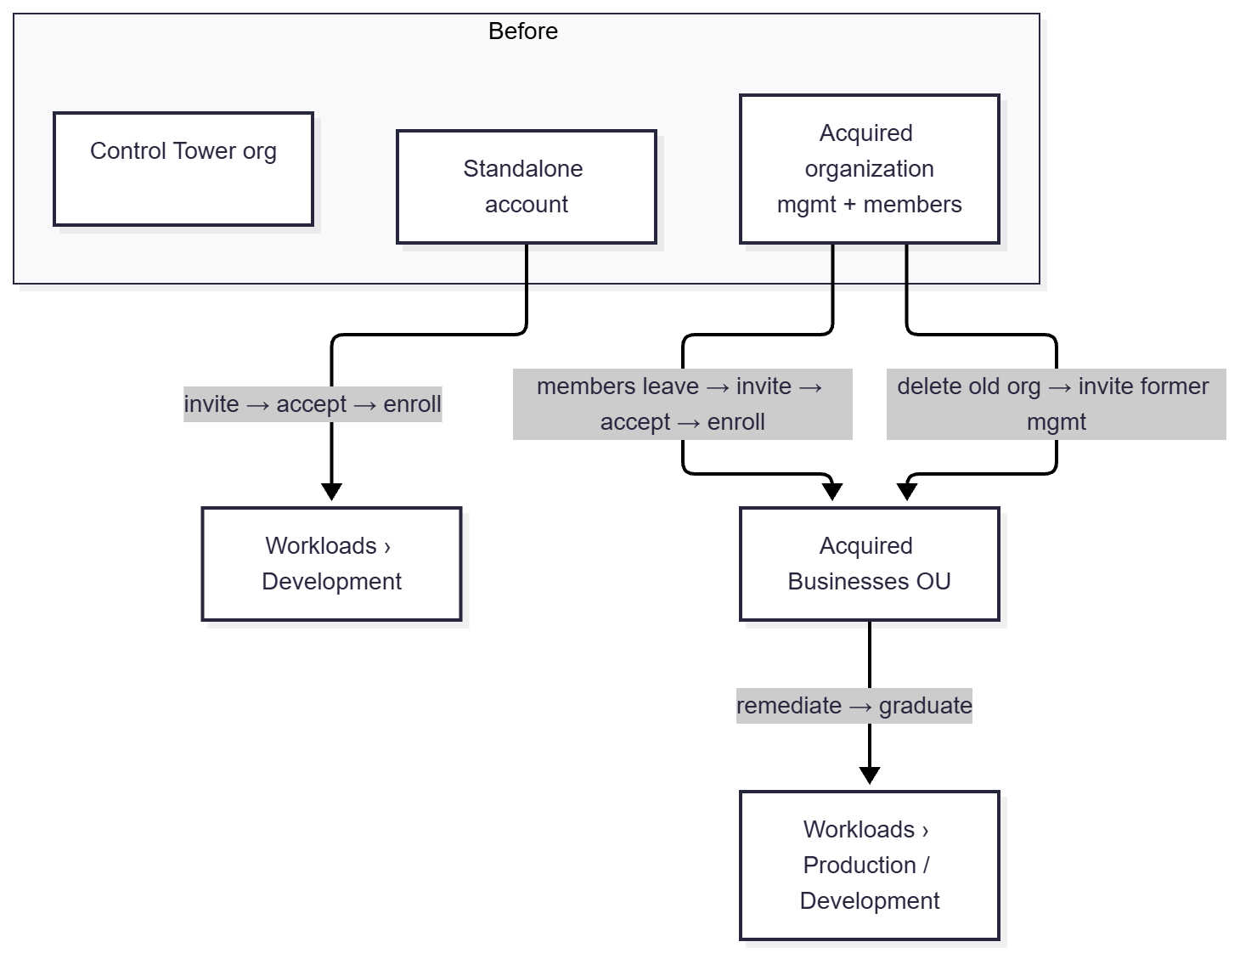
Standalone Account Integration
Target: Workloads OU > Development OU. If the assessment shows it already serves production users, it goes to Production instead.
- Assess the account (owner: cloud architect + the project manager)
  - Inventory workloads, VPC CIDRs (check for overlap with the existing plan), IAM users and access keys, and monthly spend.
  - Check for existing AWS config recorders and delivery channels and CloudTrail trails. These can conflict with Control Tower enrollment
  - Secure the root user: MFA on, no root access keys. Record the root email owner.
- Prepare the landing zone
  - Confirm the Workloads and Development OUs are registered in Control Tower
- Invite the account from the management account: AWS Organizations > Add an AWS account > Invite an existing AWS account (account ID)
- Accept the invitation inside the standalone account: AWS Organizations > Invitations > Accept. It’s now a member under Root, and consolidated billing starts.
- Grant Control Tower access: create the IAM role AWSControlTowerExecution in the account, with AdministratorAccess and a trust policy for the management account.
- Resolve conflicts: remove or adapt the pre-existing Config recorder and delivery channel (or follow AWS’s procedure for enrolling accounts with existing Config resources). Keep application trails, but rely on the organization trail for audit.
- Move the account to Workloads > Development (Organizations > Actions > Move).
- Enroll it in Control Tower (Organization view > select the account > Enroll). Control Tower applies the baseline: org CloudTrail, Config, controls and IAM Identity Center access.
- Post-enrollment hardening
  - Migrate local IAM users to IAM Identity Center, then delete the users and their access keys
  - Apply the tagging standard, and a budget
  - Verify in the Control Tower dashboard: Enrolled, no drift, controls compliant.

Acquired Organization Integration
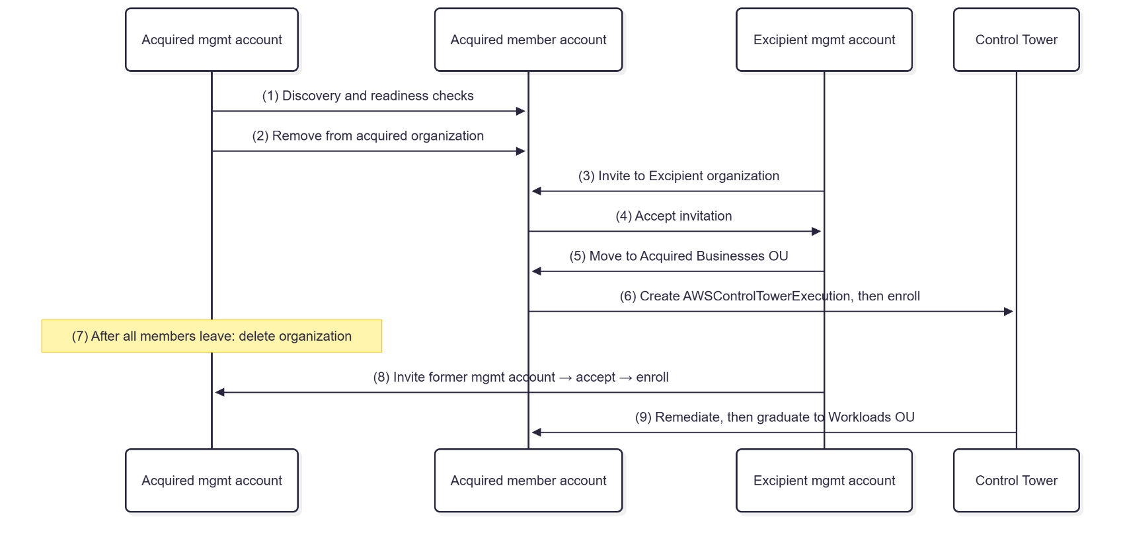

Constraint: an AWS account can be a member of only one org, and orgs can’t be merged. Every acquired account must leave its organization and join Excipient’s. The acquired management account can’t leave its own organization, so that organization must be deleted after its members are gone.
- Discovery and planning
  - Inventory the acquired org’s accounts, OU tree, SCPs, tag policies, identity setup, and workloads
  - Record every VPC CIDR and flag overlaps with Excipient ranges. Overlap blocks peering and must be re-addressed before connecting.
  - Review billing: Reserved Instance and Savings Plan sharing stops when accounts leave, and invoices split mid-month.
- Make each member account standalone-ready. To leave, each account needs its own payment method, contact info, and an accessible root user. Confirm a break-glass admin path.
- Translate governance. Map the acquired SCPs to Excipient’s policies. Note anything they enforced that Excipient doesn’t and vice versa.
- Register the Acquired Businesses OU in Control Tower and attach its quarantine SCP.
- Remove each member account from the acquired org (old management account > Organizations > Remove from organization, or the member leaves).
- Invite and accept: Excipient’s management account invites each account, and each account accepts.
- Move the accounts to the Acquired Businesses OU, create AWSControlTowerExecution in each, and enroll them in Control Tower.
- Retire the old org, once no members remain, delete the acquired org from its management account. Then invite, accept, place, and enroll the former management account like the others
- Integrate the network through the hub in ET-SharedServices: VPC peering for specific pairs, and a transit gateway as the number of VPCs grows.
- Graduate: once tagging, encryption, identity, and config compliance pass, move each account to Workloads > Production or Development. The OU’s stricter guardrails apply automatically.

Governance and Security Policies
Governance is enforced in two layers: AWS Control Tower controls across the landing zone, and service control policies (SCPs) attached per OU. SCPs cap what IAM can grant and inherit downward from Root to OUs to accounts; they never apply to the management account. Each SCP exempts the Control Tower execution role so the landing zone keeps working, and every SCP is tested in a staging OU before it is attached.
AWS Control Tower controls
Guidance | Controls | Scope
Mandatory (always on) | Protect Log Archive buckets, CloudTrail, AWS Config and Control Tower roles | Whole landing zone
Strongly recommended | Disallow root access keys; detect root MFA disabled; detect public S3 buckets and RDS instances; detect unrestricted SSH | All registered OUs
Elective | Disallow changes to S3 replication, encryption and logging settings | Corporate, Production
Proactive | Require encryption at rest for new data stores deployed through CloudFormation | Workloads

Service control policies per OU
SCP | Attached to | Purpose
ET-Root-Baseline | Root | Accounts cannot leave the organization; audit services (CloudTrail, Config) are protected; no root-user activity
ET-Workloads-Guardrails | Workloads OU | Require encrypted EBS; no local IAM users or access keys (IAM Identity Center only); account-level S3 Block Public Access cannot be changed
ET-RequireTags | Workloads OU, Acquired Businesses OU | Deny resource creation without required tags (detailed in Step 3)
ET-Dev-CostGuardrails | Development OU | Limit EC2 to approved low-cost instance families
ET-Acquired-Quarantine | Acquired Businesses OU | No new internet gateways or VPC peering and no local IAM users, except for the platform network team

ET-Root-Baseline (Root)
{
"Version": "2012-10-17",
"Statement": [
{
"Sid": "DenyLeavingOrganization",
"Effect": "Deny",
"Action": "organizations:LeaveOrganization",
"Resource": "*"
},
{
"Sid": "ProtectAuditServices",
"Effect": "Deny",
"Action": [
"cloudtrail:StopLogging",
"cloudtrail:DeleteTrail",
"config:StopConfigurationRecorder",
"config:DeleteConfigurationRecorder",
"config:DeleteDeliveryChannel"
],
"Resource": "*",
"Condition": {
"ArnNotLike": { "aws:PrincipalArn": "arn:aws:iam::*:role/AWSControlTowerExecution" }
}
},
{
"Sid": "DenyRootUserActions",
"Effect": "Deny",
"Action": "*",
"Resource": "*",
"Condition": { "StringLike": { "aws:PrincipalArn": "arn:aws:iam::*:root" } }
}
]
}

ET-Workloads-Guardrails (Workloads OU)
{
"Version": "2012-10-17",
"Statement": [
{
"Sid": "RequireEncryptedEBS",
"Effect": "Deny",
"Action": "ec2:CreateVolume",
"Resource": "*",
"Condition": { "Bool": { "ec2:Encrypted": "false" } }
},
{
"Sid": "NoLocalIAMUsersOrKeys",
"Effect": "Deny",
"Action": ["iam:CreateUser", "iam:CreateAccessKey"],
"Resource": "*",
"Condition": {
"ArnNotLike": { "aws:PrincipalArn": "arn:aws:iam::*:role/AWSControlTowerExecution" }
}
},
{
"Sid": "ProtectS3AccountPublicAccessBlock",
"Effect": "Deny",
"Action": "s3:PutAccountPublicAccessBlock",
"Resource": "*",
"Condition": {
"ArnNotLike": { "aws:PrincipalArn": "arn:aws:iam::*:role/AWSControlTowerExecution" }
}
}
]
}

ET-Dev-CostGuardrails (Development OU)
{
"Version": "2012-10-17",
"Statement": [
{
"Sid": "AllowOnlyApprovedInstanceFamilies",
"Effect": "Deny",
"Action": "ec2:RunInstances",
"Resource": "arn:aws:ec2:*:*:instance/*",
"Condition": {
"StringNotLike": { "ec2:InstanceType": ["t3.*", "t3a.*", "m6i.large", "m6i.xlarge"] }
}
}
]
}

ET-Acquired-Quarantine (Acquired Businesses OU)
{
"Version": "2012-10-17",
"Statement": [
{
"Sid": "NoNewInternetExposureOrPeering",
"Effect": "Deny",
"Action": [
"ec2:CreateInternetGateway",
"ec2:AttachInternetGateway",
"ec2:CreateVpcPeeringConnection",
"ec2:AcceptVpcPeeringConnection"
],
"Resource": "*",
"Condition": {
"ArnNotLike": {
"aws:PrincipalArn": [
"arn:aws:iam::*:role/AWSControlTowerExecution",
"arn:aws:iam::*:role/ET-PlatformNetworkAdmin"
]
}
}
},
{
"Sid": "NoLocalIAMUsers",
"Effect": "Deny",
"Action": ["iam:CreateUser", "iam:CreateAccessKey"],
"Resource": "*",
"Condition": {
"ArnNotLike": { "aws:PrincipalArn": "arn:aws:iam::*:role/AWSControlTowerExecution" }
}
}
]
}

Region restriction is applied with the Control Tower Region deny landing-zone setting rather than a hand-written SCP, because it already exempts global services correctly.

Network Connectivity Plan (Step 2)
Objective: Establish VPC peering connectivity between accounts.

3.1 Network Architecture
- Scenario Details:
  - The company has applications distributed across VPCs in different accounts. Secure connectivity must be established for inter-application communication.
Implementation
Account A hosts the company database in a private VPC (10.0.0.0/16); Account B hosts the analytics application in a separate VPC (192.168.0.0/16). The Udacity Cloud Lab provides a single AWS account, so the two accounts were represented by two AWS Regions — us-east-1 (Account A) and us-west-1 (Account B) — connected with inter-Region VPC peering, which the rubric permits (“separate accounts or Regions”). The test instances sit in public subnets only so they can be reached with EC2 Instance Connect; in production the database would live in private subnets with no internet route.
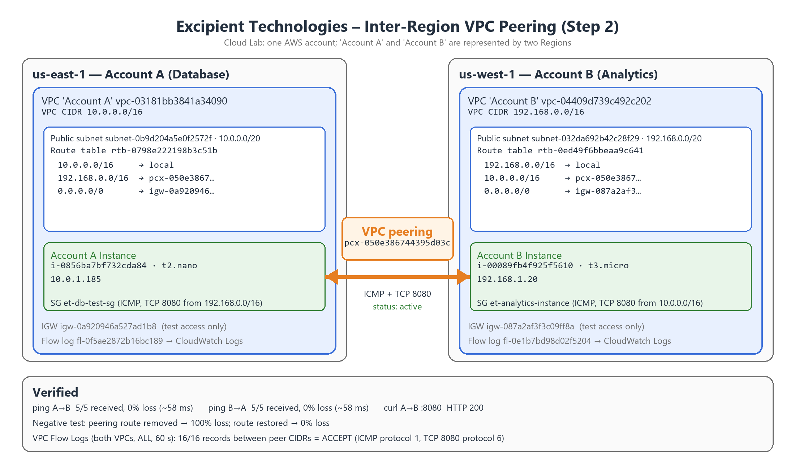
Figure 2.1 – Network architecture: two VPCs in separate Regions joined by peering connection pcx-050e386744395d03c, with flow logs on both VPCs.

3.2 VPC Peering Setup
- Instructions:
  - Create VPC peering connections between Account A and Account B.
  - Update route tables in both VPCs to allow traffic flow.
  - Configure security groups to permit communication between instances.
Implementation details
Resources. Values verified against an AWS CLI export of both Regions taken on 2026-10-18.
Item | Account A (us-east-1) | Account B (us-west-1)
VPC | vpc-03181bb3841a34090 | vpc-04409d739c492c202
VPC CIDR | 10.0.0.0/16 | 192.168.0.0/16
Subnet / CIDR / AZ | subnet-0b9d204a5e0f2572f · 10.0.0.0/20 · us-east-1e | subnet-032da692b42c28f29 · 192.168.0.0/20 · us-west-1c
Route table (associated) | rtb-0798e222198b3c51b | rtb-0ed49f6bbeaa9c641
Route table association | rtbassoc-0e69ece44ffde7243 | rtbassoc-0f908bf10669db35e
Internet gateway | igw-0a920946a527ad1b8 | igw-087a2af3f3c09ff8a
Instance | i-0856ba7bf732cda84 (t2.nano) | i-00089fb4f925f5610 (t3.micro)
Private IPv4 | 10.0.1.185 | 192.168.1.20
Status checks | ok / ok | ok / ok

Peering connection.
Field | Value
Peering connection ID | pcx-050e386744395d03c
Requester | vpc-03181bb3841a34090 (Account A), us-east-1, 10.0.0.0/16
Accepter | vpc-04409d739c492c202 (Account B), us-west-1, 192.168.0.0/16
Status | Active (confirmed from both Regions)

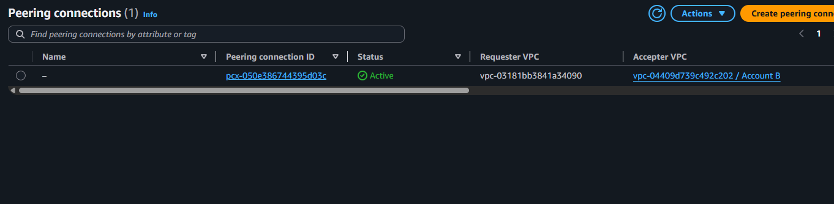
Figure 2.2 – Peering connection pcx-050e386744395d03c in the Active state.
Route table updates. Each VPC routes the other VPC’s CIDR through the peering connection.
Route table | Destination | Target | State
rtb-0798e222198b3c51b | 192.168.0.0/16 | pcx-050e386744395d03c | active
(us-east-1, Account A) | 10.0.0.0/16 | local | active
 | 0.0.0.0/0 | igw-0a920946a527ad1b8 (test access) | active
rtb-0ed49f6bbeaa9c641 | 10.0.0.0/16 | pcx-050e386744395d03c | active
(us-west-1, Account B) | 192.168.0.0/16 | local | active
 | 0.0.0.0/0 | igw-087a2af3f3c09ff8a (test access) | active

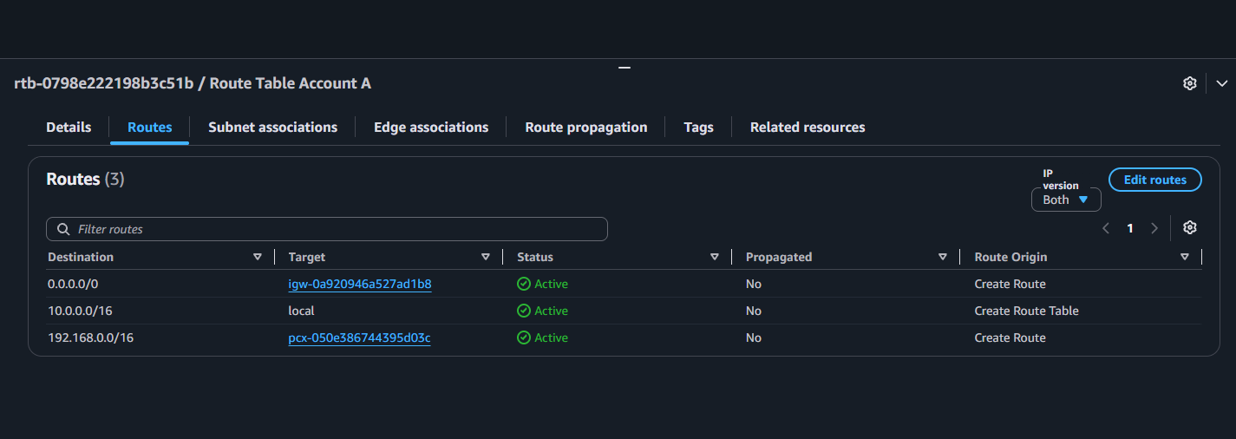
Figure 2.3 – us-east-1 route table: 192.168.0.0/16 → pcx-050e386744395d03c.
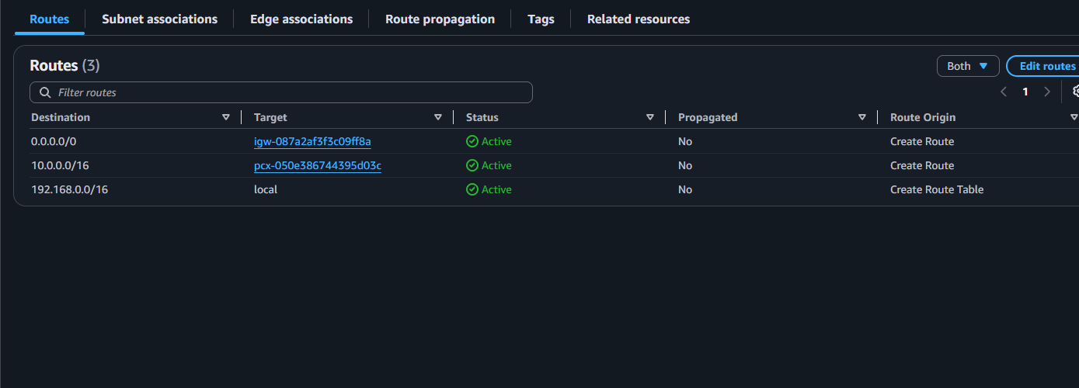
Figure 2.4 – us-west-1 route table: 10.0.0.0/16 → pcx-050e386744395d03c.
Security groups. Cross-Region peering cannot reference the peer’s security group, so rules use the peer CIDR. Only the required ports are opened to the peer.
Security group | Inbound rule | Source | Purpose
et-db-test-sg sg-0a445ec381aadfd4b | All ICMP – IPv4 | 192.168.0.0/16 | Ping from analytics
(us-east-1) | TCP 8080 | 192.168.0.0/16 | Application test traffic
 | TCP 22 | pl-0e4bcff02b13bef1e (EC2 Instance Connect) | Admin login (test only)
et-analytics-instance sg-0c25c71ec933935fe | All ICMP – IPv4 | 10.0.0.0/16 | Ping from database VPC
(us-west-1) | TCP 8080 | 10.0.0.0/16 | Application test traffic
 | TCP 22 | pl-0e99958a47b22d6ab (EC2 Instance Connect) | Admin login (test only)

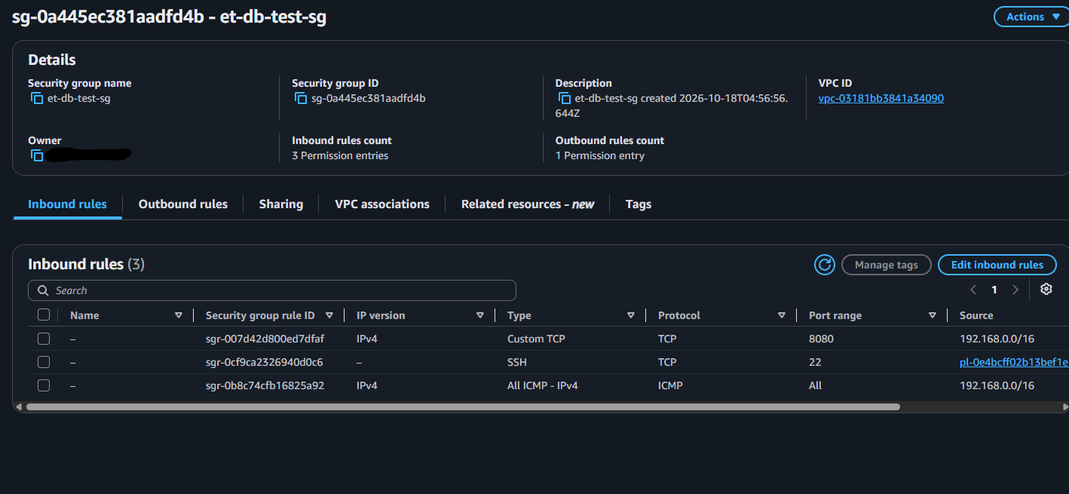
Figure 2.5 – et-db-test-sg inbound rules (us-east-1); account owner ID redacted.
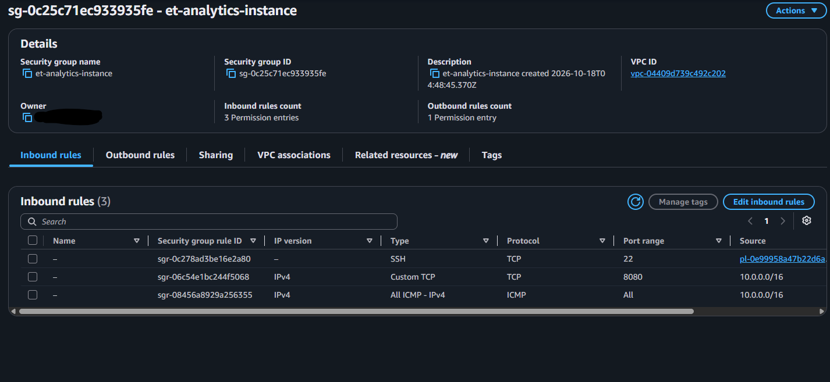
Figure 2.6 – et-analytics-instance inbound rules (us-west-1); account owner ID redacted.
Network ACLs. Explicit allow rules were added ahead of the default rule 100 (which is retained). NACLs are stateless, so the reply direction (ephemeral ports 1024–65535) is explicitly allowed for the TCP 8080 test.
Network ACL | Direction | Rule # | Protocol / ports | Peer CIDR | Action
acl-0b86ac012751aa9ce | Inbound | 90 | ICMP | 192.168.0.0/16 | Allow
(A, us-east-1) | Inbound | 91 | TCP 1024–65535 | 192.168.0.0/16 | Allow
 | Outbound | 90 | ICMP | 192.168.0.0/16 | Allow
 | Outbound | 91 | TCP 8080 | 192.168.0.0/16 | Allow
acl-0d7824466427fe00b | Inbound | 90 | ICMP | 10.0.0.0/16 | Allow
(B, us-west-1) | Inbound | 91 | TCP 8080 | 10.0.0.0/16 | Allow
 | Outbound | 90 | ICMP | 10.0.0.0/16 | Allow
 | Outbound | 91 | TCP 1024–65535 | 10.0.0.0/16 | Allow

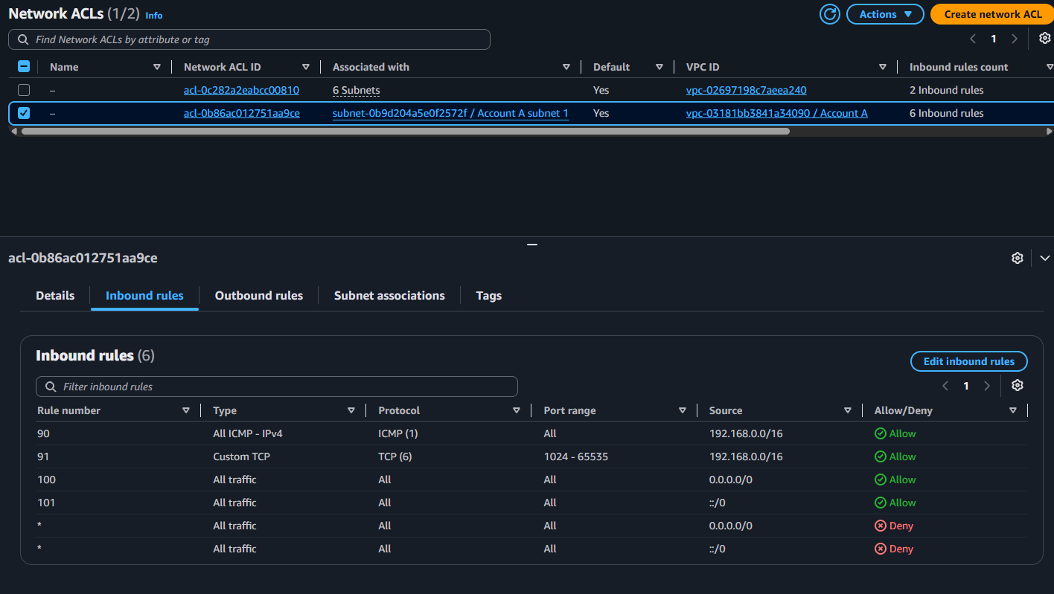
Figure 2.7 – NACL acl-0b86ac012751aa9ce (us-east-1) inbound rules 90/91 ahead of defaults.
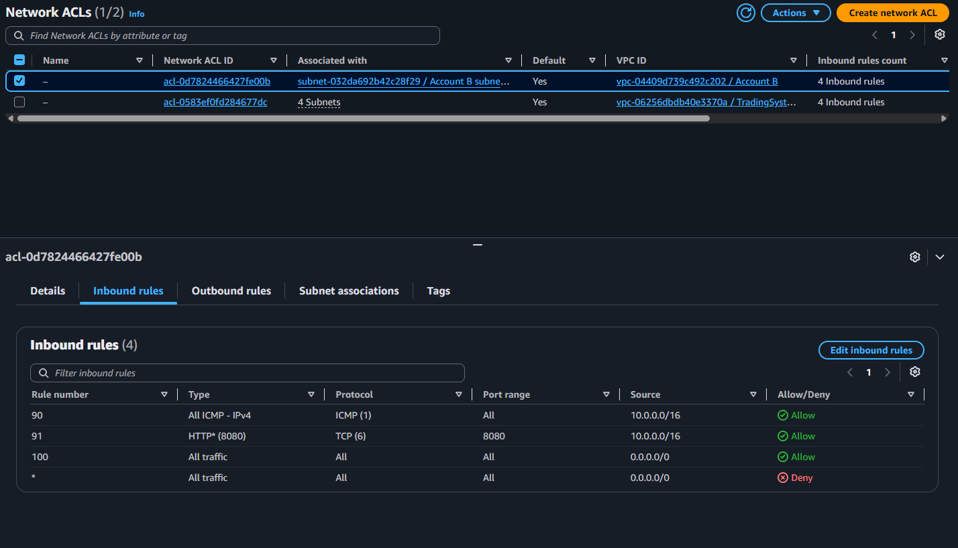
Figure 2.8 – NACL acl-0d7824466427fe00b (us-west-1) inbound rules 90/91 ahead of defaults.

3.3 Verification
- Instructions:
  - Launch EC2 instances in each VPC.
  - Test connectivity using tools like ping or curl.
  - Enable VPC Flow Logs to monitor traffic.
Verification results
Test | Command | Expected | Result
Ping A → B | ping -c 5 192.168.1.20 | 5/5 received | 5/5 received, 0% loss, avg ≈ 58 ms
HTTP A → B | curl -s -o /dev/null -w "HTTP %{http_code}\n" http://192.168.1.20:8080/ | HTTP 200 | HTTP 200
Ping B → A | ping -c 5 10.0.1.185 | 5/5 received | 5/5 received, 0% loss, avg ≈ 58 ms
Negative test | Remove peering route, ping, re-add route, ping | 100% loss, then restored | 100% loss without the route; 0% loss (avg 58.01 ms) after restoring

Ping A → B (from Account A instance 10.0.1.185):
PING 192.168.1.20 (192.168.1.20) 56(84) bytes of data.
64 bytes from 192.168.1.20: icmp_seq=1 ttl=127 time=57.7 ms
64 bytes from 192.168.1.20: icmp_seq=2 ttl=127 time=58.0 ms
64 bytes from 192.168.1.20: icmp_seq=3 ttl=127 time=57.7 ms
64 bytes from 192.168.1.20: icmp_seq=4 ttl=127 time=57.7 ms
64 bytes from 192.168.1.20: icmp_seq=5 ttl=127 time=58.1 ms
--- 192.168.1.20 ping statistics ---
5 packets transmitted, 5 received, 0% packet loss, time 4006ms
rtt min/avg/max/mdev = 57.683/57.830/58.056/0.160 ms

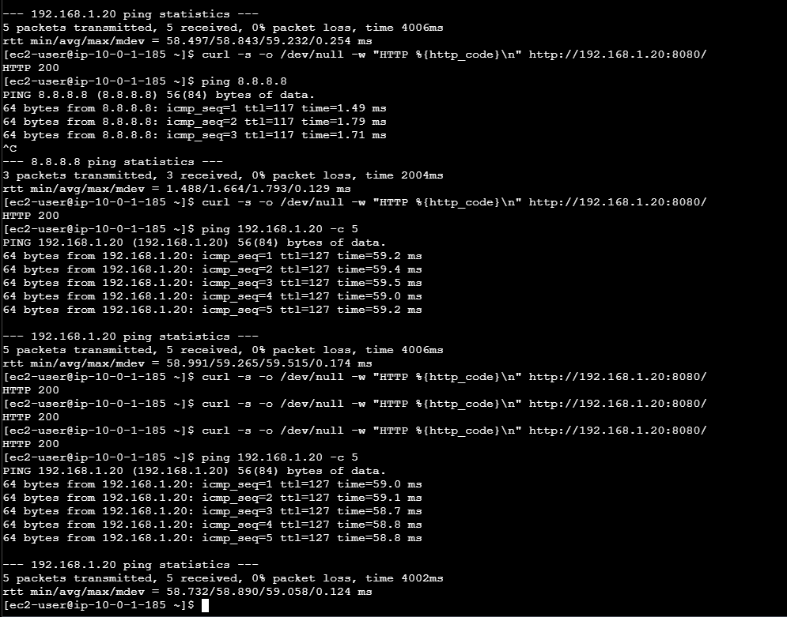
Figure 2.9 – Account A instance: ping A → B (0% loss) and repeated curl to 192.168.1.20:8080 returning HTTP 200.
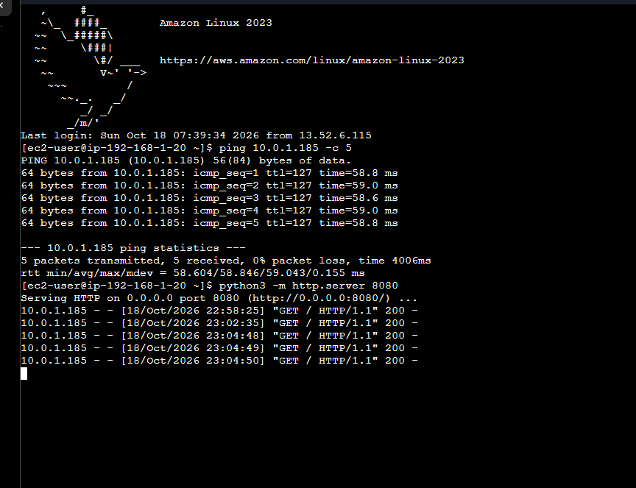
Figure 2.10 – Account B instance: ping B → A (0% loss) and the HTTP server log showing GET / 200 requests from 10.0.1.185.
Negative test. With the peering route removed, the ping from Account B to 10.0.1.185 failed (5 transmitted, 0 received, 100% packet loss); after the route was restored it succeeded again. This proves the traffic depends on the peering route and is not reaching the other VPC by any other path.
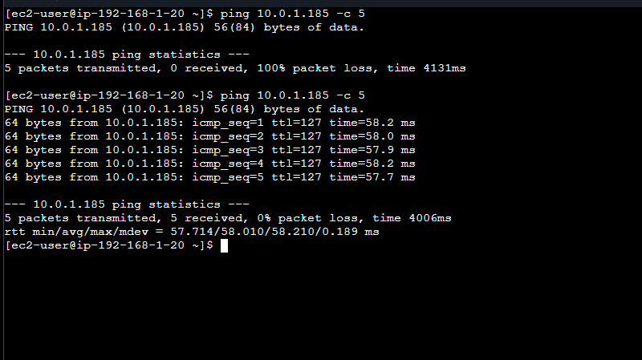
Figure 2.11 – Negative test: 100% loss without the peering route, 0% loss after restoring it.
VPC Flow Logs. Enabled on both VPCs before testing (all traffic, 60-second aggregation, CloudWatch Logs via IAM role et-flowlogs-role).
Flow log | VPC / Region | Status | Traffic | Destination
fl-0f5ae2872b16bc189 | Account A / us-east-1 | ACTIVE | ALL | /et/project/vpcflowlogs
fl-0e1b7bd98d02f5204 | Account B / us-west-1 | ACTIVE | ALL | /et/project/vpcflowlogs

CloudWatch Logs Insights query (filter on traffic between the peer CIDRs):
fields @timestamp, srcAddr, dstAddr, srcPort, dstPort, protocol, action, bytes
| filter (srcAddr like "10.0." and dstAddr like "192.168.")
or (srcAddr like "192.168." and dstAddr like "10.0.")
| sort @timestamp desc | limit 50

Result: 16 of 16 matching records, all ACCEPT, in both directions (2026-10-18, 22:58–23:05 UTC). Representative records:
Time (UTC) | Source | Destination | Src port | Dst port | Proto | Action | Bytes | Meaning
23:05:28 | 10.0.1.185 | 192.168.1.20 | 53508 | 8080 | 6 | ACCEPT | 349 | curl request A→B
23:05:28 | 192.168.1.20 | 10.0.1.185 | 8080 | 53508 | 6 | ACCEPT | 945 | HTTP 200 reply B→A
23:05:28 | 10.0.1.185 | 192.168.1.20 | 0 | 0 | 1 | ACCEPT | 420 | ping requests A→B
23:05:28 | 192.168.1.20 | 10.0.1.185 | 0 | 0 | 1 | ACCEPT | 420 | ping replies B→A

Protocol 1 = ICMP (ping) and protocol 6 with destination port 8080 = the HTTP test; 5 pings × 84 bytes = 420 bytes. The HTTP reply returns to the client’s ephemeral port (e.g. 53508), which is why the NACLs needed the 1024–65535 reply rules.
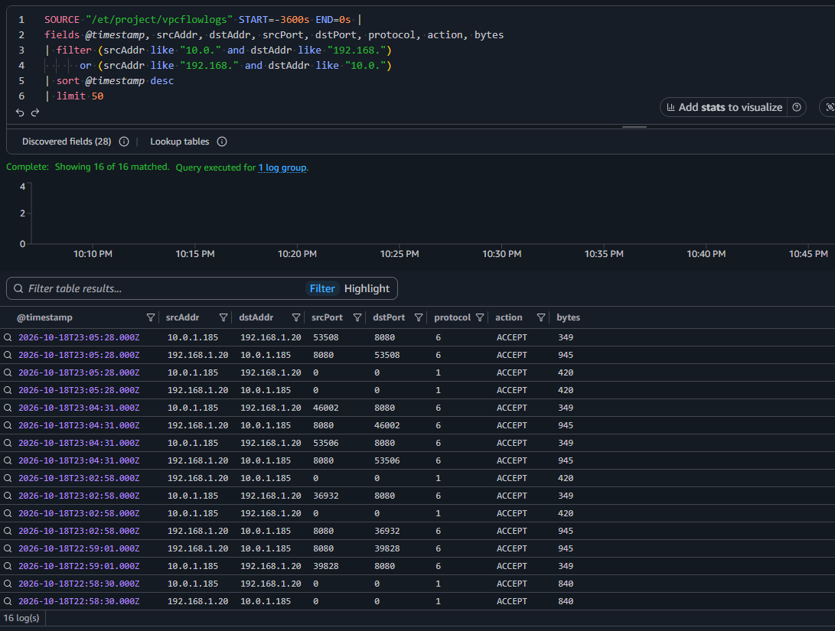
Figure 2.12 – CloudWatch Logs Insights: 16/16 flow log records between the peer CIDRs are ACCEPT.
Conclusion. Traffic flows privately between the two VPCs over the active inter-Region peering connection pcx-050e386744395d03c in both directions, demonstrated by 0%-loss pings each way (~58 ms), an HTTP 200 on TCP 8080, a negative test that fails without the peering route, and ACCEPT flow log records on both VPCs. The route tables (with correct subnet associations), security groups (peer-CIDR rules) and NACLs (explicit stateless allow rules) together permit exactly the required inter-VPC traffic.

Deliverables:
- Connectivity deliverables :
  - Details of VPC peering setup (connection IDs, routes).
  - Screenshots of successful connectivity testing.
  - Logs showing traffic flow [optional]
Deliverables provided above: VPC diagram and description (3.1, Figure 2.1); peering connection ID, route table, security group and NACL details (3.2, Figures 2.2–2.8); connectivity screenshots for ping and curl (3.3, Figures 2.9–2.11); and VPC Flow Logs showing traffic flow (3.3, Figure 2.12). All resources were created in the Udacity Cloud Lab and removed after verification.

Governance with Tagging Strategies (Step 3)
Objective: Define and enforce a tagging strategy using SCPs and AWS Config rules.
4.1 Tagging Strategy
- Scenario Details:
  - Excipient Technologies uses tagging for:
    - Tracking environments (Development, Production).
    - Assigning cost centers (e.g., R&D, Marketing).
    - Identifying resource owners.
- Instructions:
  - Create a table specifying:
    - Tags (e.g., Environment, CostCenter, Owner).
    - Example values for each tag.
    - Purpose of each tag.
4.2 Enforcing Tagging Compliance
- Instructions:
  - Write an SCP to deny the creation of resources without required tags.
  - Draft an AWS Config rule to detect non-compliant resources.
Deliverables:
- Tagging strategy table.
- SCP JSON example.
- AWS Config rule JSON example.

Tagging Strategy Table

Category | Key | Value | Purpose
Operational / lifecycle | Environment | Development, Test, Production | Identifies the lifecycle stage. Drives which guardrails, budgets, and schedules apply: dev resources can be stopped by budget actions, production can't. Required.
Financial | CostCenter | R&D, Marketing, Manufacturing, Corporate-IT | Allocates spend to the department that pays. Activated as a cost allocation tag so it appears in Cost Explorer and the CUR for chargeback. Required.
Ownership | Owner | Team alias, e.g. research-platform-team, analytics-team | Accountable team for operations, incidents, and cleanup ("whose instance is this?"). A team alias, never a person's name or email. Required.
Business | Project | e.g. CompoundScreening, ClinicalAnalytics, PM-Project | Ties resources to a program or product line for showback and anomaly monitoring. Recommended.
Security / compliance | DataClassification | Public, Internal, Confidential, GxP-Regulated | Flags data sensitivity and regulated (GxP) systems for stricter controls and audit scope. Recommended.

Enforcing Tagging Compliance
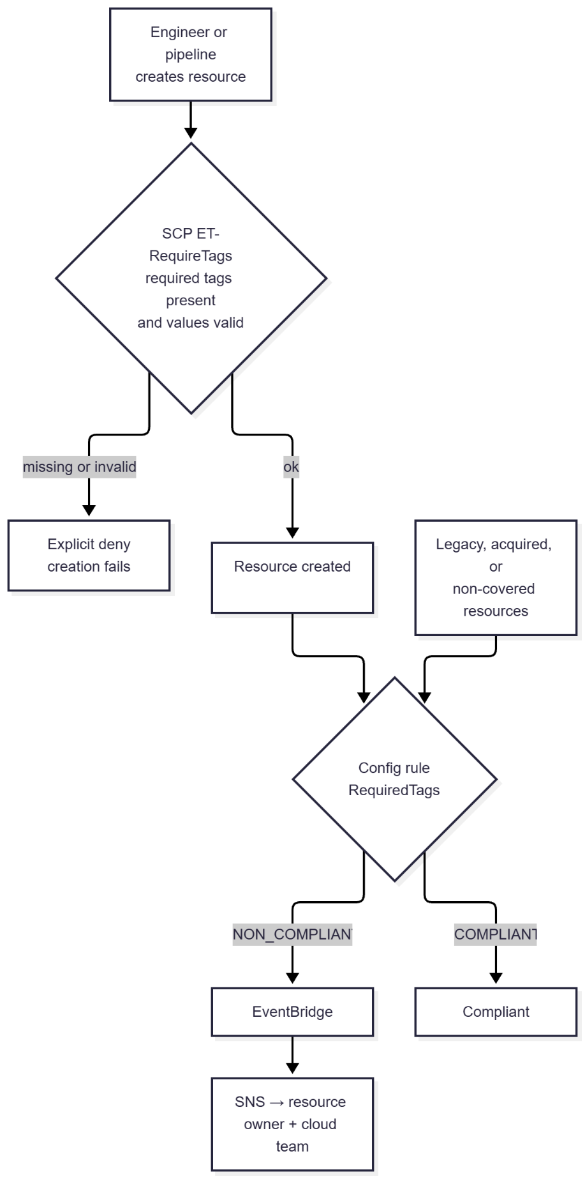
Layer | Tool | Mode | Scope
Prevent | SCP ET-RequireTags | Deny creation without required tags or with invalid values | Workloads OU and Acquired Businesses OU
Detect | AWS Config managed rule REQUIRED_TAGS | Flag non-compliant existing resources | All accounts (organization rule)
Notify | EventBridge → SNS | Alert owners on NON_COMPLIANT | Organization
Standardize (supporting) | Tag policy | Enforce key casing and allowed values | Organization

SCP Policy (JSON) :
ET-RequireTags, attached to the Workloads OU and the Acquired Businesses OU. Each required key gets its own Null statement. Several keys inside one Null block are ANDed, so the deny would only fire if all were missing.

{
"Version": "2012-10-17",
"Statement": [
{
"Sid": "DenyEC2WithoutEnvironmentTag",
"Effect": "Deny",
"Action": ["ec2:RunInstances", "ec2:CreateVolume"],
"Resource": ["arn:aws:ec2:*:*:instance/*", "arn:aws:ec2:*:*:volume/*"],
"Condition": { "Null": { "aws:RequestTag/Environment": "true" } }
},
{
"Sid": "DenyEC2WithoutCostCenterTag",
"Effect": "Deny",
"Action": ["ec2:RunInstances", "ec2:CreateVolume"],
"Resource": ["arn:aws:ec2:*:*:instance/*", "arn:aws:ec2:*:*:volume/*"],
"Condition": { "Null": { "aws:RequestTag/CostCenter": "true" } }
},
{
"Sid": "DenyEC2WithoutOwnerTag",
"Effect": "Deny",
"Action": ["ec2:RunInstances", "ec2:CreateVolume"],
"Resource": ["arn:aws:ec2:*:*:instance/*", "arn:aws:ec2:*:*:volume/*"],
"Condition": { "Null": { "aws:RequestTag/Owner": "true" } }
},
{
"Sid": "DenyRDSWithoutRequiredTags",
"Effect": "Deny",
"Action": "rds:CreateDBInstance",
"Resource": "arn:aws:rds:*:*:db:*",
"Condition": { "Null": { "aws:RequestTag/Environment": "true" } }
},
{
"Sid": "DenyRDSWithoutCostCenter",
"Effect": "Deny",
"Action": "rds:CreateDBInstance",
"Resource": "arn:aws:rds:*:*:db:*",
"Condition": { "Null": { "aws:RequestTag/CostCenter": "true" } }
},
{
"Sid": "DenyRDSWithoutOwner",
"Effect": "Deny",
"Action": "rds:CreateDBInstance",
"Resource": "arn:aws:rds:*:*:db:*",
"Condition": { "Null": { "aws:RequestTag/Owner": "true" } }
},
{
"Sid": "DenyInvalidEnvironmentValues",
"Effect": "Deny",
"Action": ["ec2:RunInstances", "ec2:CreateVolume", "rds:CreateDBInstance"],
"Resource": "*",
"Condition": {
"StringNotEqualsIfExists": {
"aws:RequestTag/Environment": ["Development", "Test", "Production"]
}
}
},
{
"Sid": "DenyInvalidCostCenterValues",
"Effect": "Deny",
"Action": ["ec2:RunInstances", "ec2:CreateVolume", "rds:CreateDBInstance"],
"Resource": "*",
"Condition": {
"StringNotEqualsIfExists": {
"aws:RequestTag/CostCenter": ["R&D", "Marketing", "Manufacturing", "Corporate-IT"]
}
}
},
{
"Sid": "DenyRemovingRequiredTags",
"Effect": "Deny",
"Action": ["ec2:DeleteTags", "rds:RemoveTagsFromResource"],
"Resource": "*",
"Condition": {
"ForAnyValue:StringEquals": { "aws:TagKeys": ["Environment", "CostCenter", "Owner"] },
"ArnNotLike": { "aws:PrincipalArn": "arn:aws:iam::*:role/AWSControlTowerExecution" }
}
}
]
}

AWS Config Rule (JSON) :
Per-account rule (PutConfigRule input)
{
"ConfigRuleName": "RequiredTags",
"Description": "Flags resources missing Environment, CostCenter, or Owner tags, or with invalid Environment/CostCenter values.",
"Scope": {
"ComplianceResourceTypes": [
"AWS::EC2::Instance",
"AWS::EC2::Volume",
"AWS::EC2::VPC",
"AWS::EC2::Subnet",
"AWS::EC2::SecurityGroup",
"AWS::RDS::DBInstance",
"AWS::S3::Bucket",
"AWS::DynamoDB::Table"
]
},
"Source": {
"Owner": "AWS",
"SourceIdentifier": "REQUIRED_TAGS"
},
"InputParameters": "{\"tag1Key\":\"Environment\",\"tag1Value\":\"Development,Test,Production\",\"tag2Key\":\"CostCenter\",\"tag2Value\":\"R&D,Marketing,Manufacturing,Corporate-IT\",\"tag3Key\":\"Owner\"}"
}

Organization-wide deployment (PutOrganizationConfigRule)
{
"OrganizationConfigRuleName": "RequiredTags",
"OrganizationManagedRuleMetadata": {
"RuleIdentifier": "REQUIRED_TAGS",
"Description": "Organization-wide required tag check for Excipient Technologies.",
"ResourceTypesScope": [
"AWS::EC2::Instance",
"AWS::EC2::Volume",
"AWS::RDS::DBInstance",
"AWS::S3::Bucket",
"AWS::DynamoDB::Table"
],
"InputParameters": "{\"tag1Key\":\"Environment\",\"tag1Value\":\"Development,Test,Production\",\"tag2Key\":\"CostCenter\",\"tag2Value\":\"R&D,Marketing,Manufacturing,Corporate-IT\",\"tag3Key\":\"Owner\"}"
}
}

Notification of non-compliance (EventBridge rule pattern > SNS topic et-tag-compliance):
{
"source": ["aws.config"],
"detail-type": ["Config Rules Compliance Change"],
"detail": {
"configRuleName": [{ "prefix": "RequiredTags" }],
"newEvaluationResult": { "complianceType": ["NON_COMPLIANT"] }
}
}

Cost Management Plan (Step 4)
5.1 Budget Configuration
Budgets:
# | Budget name | Scope (filter) | Amount | Alert thresholds | Notifies
1 | ET-Org-Monthly-Total | Entire organization | $60,000 | Actual 80%  Actual 100%  Forecast 100% | SNS + cloud-finance
2 | ET-Production-Workloads | Linked accounts in the Production OU | $35,000 | Actual 85%  Forecast 100%  Actual 100% | SNS + cloud-finance
3 | ET-Development-Workloads | Linked accounts in the Development OU | $8,000 | Actual 80%  Forecast 100%  Actual 100% → action | dev-leads + SNS
4 | ET-Acquired-Businesses | Linked accounts in the Acquired Businesses OU | $10,000 | Forecast 100%  Actual 90% → action (manual approval) | integration-office + SNS
5 | ET-CostCenter-RnD | Tag CostCenter = R&D | $25,000 | Actual 80%  Forecast 100% | rnd-finance
6 | ET-CostCenter-Marketing | Tag CostCenter = Marketing | $5,000 | Actual 80%  Forecast 100% | cloud-finance
7 | ET-SavingsPlans-Utilization | Savings Plans (utilization budget) | 90% target | Utilization below 90% | cloud-finance

Actions:
Action | Budget | Trigger | Type | Effect | Approval
A1 – Dev spend freeze | ET-Development-Workloads | Actual ≥ 100% | APPLY_SCP_POLICY | Attach SCP ET-Dev-SpendFreeze to the Development OU: no new EC2, RDS, or SageMaker capacity | Automatic
A2 – Stop idle dev compute | ET-Development-Workloads | Actual ≥ 100% | RUN_SSM_DOCUMENTS (STOP_EC2_INSTANCES) | Stop the listed long-running dev instances | Automatic
A3 – Acquired-accounts freeze | ET-Acquired-Businesses | Actual ≥ 90% | APPLY_SCP_POLICY | Attach ET-Dev-SpendFreeze to the Acquired Businesses OU | Manual: integration office approves
A4 – Production guard | ET-Production-Workloads | Actual ≥ 100% | APPLY_IAM_POLICY | Attach a deny-new-GPU-instances policy to the developer role (not to running workloads) | Manual: CTO/finance approve
Notification channels
Channel | Identifier (illustrative) | Audience
SNS topic | arn:aws:sns:us-east-1:111111111111:et-budget-alerts | Cloud platform on-call; forwarded to Slack/Teams via AWS Chatbot
Email | cloud-finance@excipient.example | Finance / FinOps
Email | dev-leads@excipient.example | Development team leads
Email | integration-office@excipient.example | Acquisition integration team
Email | rnd-finance@excipient.example | R&D cost-center owner

All budgets are monthly cost budgets in USD created in the management account, which sees consolidated billing for every account and is the only account that can run SCP budget actions. Production uses alerts and manual approval only — never automatic shutdown — because halting validated (GxP) or analytics systems costs more than the overspend.
Example budget definition (aws budgets create-budget input)
{
"BudgetName": "ET-Development-Workloads",
"BudgetLimit": { "Amount": "8000", "Unit": "USD" },
"TimeUnit": "MONTHLY",
"BudgetType": "COST",
"CostFilters": { "LinkedAccount": ["222222222222", "333333333333", "444444444444"] }
}

Example budget action A1 (create-budget-action input)
{
"BudgetName": "ET-Development-Workloads",
"NotificationType": "ACTUAL",
"ActionType": "APPLY_SCP_POLICY",
"ActionThreshold": { "ActionThresholdValue": 100.0, "ActionThresholdType": "PERCENTAGE" },
"Definition": { "ScpActionDefinition": { "PolicyId": "p-etdevfreeze1", "TargetIds": ["ou-et12-devwrkld"] } },
"ExecutionRoleArn": "arn:aws:iam::111111111111:role/ET-BudgetsActionRole",
"ApprovalModel": "AUTOMATIC",
"Subscribers": [
{ "SubscriptionType": "SNS", "Address": "arn:aws:sns:us-east-1:111111111111:et-budget-alerts" },
{ "SubscriptionType": "EMAIL", "Address": "dev-leads@excipient.example" }
]
}

Spend-freeze SCP ET-Dev-SpendFreeze (applied by actions A1 and A3)
{
"Version": "2012-10-17",
"Statement": [
{
"Sid": "FreezeNewCapacity",
"Effect": "Deny",
"Action": [
"ec2:RunInstances", "ec2:CreateNatGateway",
"rds:CreateDBInstance", "rds:CreateDBCluster",
"sagemaker:CreateNotebookInstance", "sagemaker:CreateTrainingJob", "sagemaker:CreateEndpoint"
],
"Resource": "*",
"Condition": {
"ArnNotLike": { "aws:PrincipalArn": [
"arn:aws:iam::*:role/AWSControlTowerExecution",
"arn:aws:iam::*:role/ET-PlatformBreakGlass" ] }
}
}
]
}

Simulated Outputs
The following outputs are simulated to show how the configured budgets and actions behave during a month in which Development overspends. Account IDs, ARNs and email addresses are illustrative.
Alert emails (simulated)
Subject: AWS Budgets: ET-Development-Workloads has exceeded your alert threshold
Budget name: ET-Development-Workloads Budget type: Cost
Budgeted amount: $8,000.00 Alert type: ACTUAL
Alert threshold: > 80.00% ACTUAL amount: $6,450.27 (80.63% of budget)

Subject: AWS Budgets: ET-Development-Workloads is forecasted to exceed your threshold
Alert type: FORECASTED Alert threshold: > 100.00% FORECASTED amount: $8,960.00 (112.00%)

SNS message delivered to Slack via AWS Chatbot (simulated)
{
"budgetName": "ET-Development-Workloads",
"notificationType": "ACTUAL",
"threshold": "100.0%",
"actualSpend": "8021.44 USD",
"budgetLimit": "8000.00 USD",
"actionTriggered": ["A1-DevSpendFreeze", "A2-StopIdleDevCompute"]
}

Budget action execution history (simulated describe-budget-action-histories)
Time (UTC) | Action | Status | Detail
Day 26 14:05 | A1 – Dev spend freeze | STANDBY → EXECUTION_IN_PROGRESS | Threshold 100% reached ($8,021.44)
Day 26 14:06 | A1 – Dev spend freeze | EXECUTION_SUCCESS | SCP p-etdevfreeze1 attached to ou-et12-devwrkld
Day 26 14:06 | A2 – Stop idle dev compute | EXECUTION_SUCCESS | i-0de0000000000aaa1, i-0de0000000000aaa2 stopped
Day 27 09:30 | A3 – Acquired freeze | PENDING (awaiting approval) | Acquired Businesses OU at 91.2%
Day 27 11:02 | A3 – Acquired freeze | EXECUTION_SUCCESS | Approved by the integration office

Enforcement seen by a developer (simulated)
$ aws ec2 run-instances --image-id ami-0abc... --instance-type t3.large ...
An error occurred (UnauthorizedOperation) when calling the RunInstances operation:
You are not authorized to perform this operation. ... with an explicit deny in a
service control policy.

Simulated month summary
Budget | Limit | Actual | % | Outcome
ET-Org-Monthly-Total | $60,000 | $51,870 | 86% | 80% alert sent; no action
ET-Production-Workloads | $35,000 | $29,400 | 84% | Below the 85% alert
ET-Development-Workloads | $8,000 | $8,021 | 100.3% | 80% and forecast alerts; actions A1 and A2 executed
ET-Acquired-Businesses | $10,000 | $9,120 | 91% | Action A3 approved and executed
ET-CostCenter-RnD | $25,000 | $21,300 | 85% | 80% alert to R&D finance
ET-SavingsPlans-Utilization | 90% | 94% | — | No alert

At the start of the next budget period, or after an approved budget increase, the platform team reverses actions A1 and A3 to remove the spend-freeze SCP.

